 | Question Paper Generator  Technical Design Document  1.0
 | Prepared By / Last Updated By | Reviewed by | Approved By
Name | Aakash Thakur,Bharat Singh,Deepak,Harshita Trivedi,Rajat Kapoor. | Anita Rananaware
Role | Team Member | Trainer
Signature
Date | 02-Apr-2019 | 26-Apr-2019

Table of Contents

1.0 Introduction 3
1.1 Purpose of this document 3
1.2 Scope 3
1.3 Intended Audience 3
1.4 Definition & Acronyms 3
2.0 Conventions and Standards Followed 4
3.0 Assumptions, Dependencies and Risks 4
3.1 Assumptions: 4
3.2 Dependencies: 4
4.0 Schematic Diagram 4
5.0 Use Case Realization 5
5.1.1 User Registration 5
a. Functional Requirement 6
b. UI Validations 6
c. UI Controls 7
d. UI Methods Definition 8
e. UI Design 9
6.0 Database Design 10
6.1 Data Model 10
6.2 Tables Structure 10
7.0 Change Log 13

Introduction

Purpose of this document
The purpose of the detail design document is to define the detailed design for all the components of Question Paper Generator that are specified in the Business Requirement/Use case document. All the low level components, interfaces and integrations are detailed out in this document.

Scope
This sub-section shall state the scope of this detailed design document
- Create and maintain student information.
- Generation of student list.

Intended Audience
The intended audience for this document are
- Developers, testers, other associates in the project
- Technical lead, Scrum Master
- Delivery assurance/excellence group

Definition & Acronyms
Acronyms | Definitions
QPG | Question Paper Generator

Conventions and Standards Followed
The modules under scope needs to adhere to the coding standards and guidelines
- C# Code Conventions and Standards Followed.

Assumptions, Dependencies and Risks

Assumptions:
- Once the application is built the QUESTION PAPER GENERATOR will manually load the user list into the system.
- There will be no concurrent users for the application. The user profile will be maintained by the user.
- Any changes to the design mentioned in the BRD would be taken as a Change Request.

Dependencies:
- Availability of database design characteristics & access shall be defined by the
- Resource availability throughout each of the sprint.

Schematic Diagram
A schematic, or schematic diagram, is a representation of the elements of a system using abstract, graphic symbols rather than realistic pictures. It gives an overview of overall system

The above pic is only an example and not representational of the Question Paper Generator

Use Case Realization

User Registration

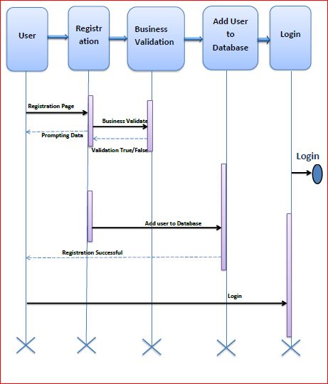

Functional Requirement
. Login Page checks the authentication of the user and based on his role, directs the user to the respective page. User will have provided with Add Student Details, and the same user will have allowed to see Selection for the Scholarship and own Student details reports.

UI Validations
- User Id and Password fields are mandatory.
- Invalid User Id and/or password should not allow the user to get into the system.

UI Controls
# | UI Component | Type | Name | Details
1 | User Id | Text field | EmpidTB | To enter userid
2 | First Name | Text field | FirstNameTB | To enter firstname
3 | Last Name | Text field | LastNameTB | To enter lastname
4 | password | Password | PasswordTB | To enter password
4 | Email | Email | EmailTB | To enter emailid

UI Methods Definition
Method Name | Parameter | Details
LoginBT | object sender, EventArgs e | Allows the user to login into the portal
LogoutBT | object sender, EventArgs e | Ends the session created by user
HomeBT | object sender, EventArgs e | Loads the Homepage after registration is done successfully.
SignupBT | object sender, EventArgs e | Allows the user to insert the User personal details
Resource List | object sender, EventArgs e | Allows admin to view user details
TakeTestBt | object sender, EventArgs e | Allows user to take test.
AddAdminBT | object sender, EventArgs e | Allows admin to add more admins
AddTestBT | object sender, EventArgs e | Allows admin to create test.

UI Design



Tables Structure
Student Registration:
Column Name | Data Type | Length | Nulls
First Name | Alphabetic | 50 | N
Last Name | Alphabetic | 50 | N
Email | Alphabetic | 50 | N
User-Id | Alphanumeric | 10 | N
Password | Alphanumeric | 15 | N

Student login:
Column Name | Data Type | Length | Nulls
User Id | nvarchar | 50 | N
Password | nvarchar | 50 | N
Admin Registration:
Column Name | Data Type | Length | Nulls
First Name | Alphabetic | 50 | N
Last Name | Alphabetic | 50 | N
Email | Alphabetic | 50 | N
User-Id |         Alphanumeric | 10 | N
Password |   Alphanumeric | 15 | N

Admin login:
Column Name | Data Type | Length | Nulls
User Id | nvarchar | 50 | N
Password | nvarchar | 50 | N

Examination:
Column Name | Data Type | Length | Nulls
Exam Id | Alphabetic | 20 | N
Exam Description | Alphabetic | 100 | N
Skill Set | Alphabetic | 20 | N
Competency Level | Alphabetic | 10 | N

Result:
Column Name | Data Type | Length | Nulls
User Id | Alphanumeric | 10 | N
Correct Answer | Numeric | 3 | N
Incorrect Answer | Numeric | 3 | N
Unattempted | Numeric | 3 | N
Total Questions | Numeric | 3 | N
Test Name | Alphanumeric | 20 | N

Question:
Column Name | Data Type | Length | Nulls
Question Id | Alphabetic | 10 | N
Question Creator | Alphanumeric | 15 | N
Question | Alphabetic | 500 | N
Choice | Alphabetic | 500 | N

Change Log
Please note that this table needs to be maintained even if a Configuration Management tool is used.
Version Number | Changes made
V1.0 | <First version>
V1.1 | <If the change details are not explicitly documented in the table below, reference should be provided here>
V1.1 | Page no | Changed by | Effective date | Changes effected
V1.2 | <If the change details are not explicitly documented in the table below, reference should be provided here>
V1.2 | Page no | Changed by | Effective date | Changes effected

